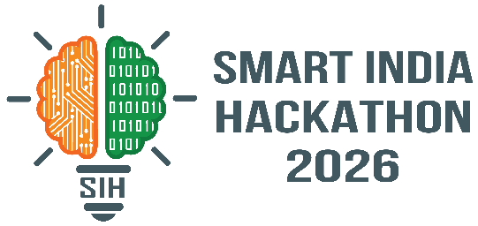
SMART INDIA HACKATHON 2026

Project Report
Project Title: JAGRUK SWADESH AI-Powered BIS Compliance & Conversational Knowledge Assistant
Team Details:
- Team Name: Team Jagruk Swadesh
- Problem Statement ID: SIH26107
- Problem Statement Title: Al-powered Intelligent Assistant for Indian Standards and BIS Services for Industries and Consumers
- Theme: Smart Automation
Submitted by:
- Om Kumar Roy (Team Leader)
- Videesh Sharma (Team Member)
- Om Jee (Team Member)
- Sonu Kumar (Team Member)
- Shruti Yadav (Team Member)
- Saurabh devliyal (Team Member)
Institution: Uttaranchal University (UIT),Prem nagar ,Dehradun, Uttarakhand

CERTIFICATE OF AUTHENTICITY
This is to certify that the project report entitled "JAGRUK SWADESH: AI-Powered BIS Compliance & Conversational Knowledge Assistant" is a bona fide record of the original software development work carried out by Team Jagruk Swadesh for the Smart India Hackathon 2026.
The system implementation, data pipelines, AI architecture, and source code described in this document were conceptualized and developed by the team members from UIT Uttarakhand to address the specific requirements of Problem Statement [Insert PS ID] provided by [Insert Ministry/Organization].
We certify that this work represents our actual implementation developed during the SIH 2026 phases and has not been copied from pre-existing unoriginal sources or submitted elsewhere for any other hackathon or degree without proper disclosure.

DECLARATION FOR SIH 2026
We, the members of Team Jagruk Swadesh, hereby declare that the prototype and report submitted for the Smart India Hackathon 2026 are entirely our original collaborative work.
We affirm that the architecture described—including the RAG implementation, the LangGraph-based "Jagruk Brain," and the automated BIS data extraction pipeline—accurately reflects the system we have deployed for evaluation. All third-party tools, APIs (including Groq and Whisper), and open-source libraries (such as React, FastAPI, and Qdrant) utilized to build this platform have been properly acknowledged in the technical stack documentation.
We agree to abide by the rules and regulations of the Smart India Hackathon 2026 and confirm that our solution aims to fulfill the vision of making Indian Standards simple and accessible.

ABSTRACT
The Bureau of Indian Standards (BIS) provides critical regulations, certifications, and quality control orders necessary for manufacturing, safety, and compliance in India. However, accessing and comprehending these extensive, highly technical documents poses a significant challenge for ordinary citizens, small business owners, and non-technical users.
Jagruk Swadesh is an AI-powered conversational platform designed to solve this problem by simplifying access to BIS standards. Serving as a bridge between complex regulatory frameworks and end-users, the platform embodies the vision: "Indian Standards Made Simple."
The system utilizes a robust microservices architecture combining a modern React web application with a Retrieval-Augmented Generation (RAG) pipeline. To ensure accuracy and prevent hallucination, the system relies on an automated data collection pipeline that ingests, structures, and embeds official BIS data into a Qdrant vector database. The "Jagruk Brain," orchestrated via a state-based pipeline, handles multimodal inputs (text and voice), processes speech using Whisper STT, performs intent extraction and query understanding, retrieves relevant evidence, and generates grounded, multilingual responses using Groq-hosted LLMs. By providing natural language voice and text interactions, Jagruk Swadesh democratizes access to regulatory knowledge, making compliance information highly accessible, reliable, and user-friendly.

TABLE OF CONTENTS
- Introduction
- Existing System and Problem Analysis
- System Overview
- Technology Stack
- BIS Data Collection and Knowledge Preparation
- RAG Knowledge Base
- Jagruk Brain AI Pipeline
- Query Understanding and AI Reasoning
- Voice and Multilingual Interaction
- Frontend Application
- Backend Architecture
- API Design and Data Flow
- Database and Data Management
- Security
- Testing and Validation
- Deployment and Setup
- Performance, Scalability and Reliability
- Limitations and Challenges
- Future Scope
- Impact and Benefits
- Conclusion
- Appendices
- WEBSITE IMAGES
LIST OF FIGURES
- Figure 4.1: Jagruk Swadesh Technology Stack
- Figure 5.1: BIS Data Collection & Document Extraction Pipeline
- Figure 7.1: Jagruk Brain Pipeline
- Figure 10.1: Jagruk Swadesh Frontend User Workflow
- Figure 11.1: Jagruk Swadesh Backend Workflow
LIST OF TABLES
- Table 2.1: Traditional BIS Information Access vs Jagruk Swadesh
- Table 3.1: System Components and Responsibilities
- Table 12.1: Core API Endpoints
- Table 15.1: Recommended Test Cases
LIST OF ABBREVIATIONS
- AI: Artificial Intelligence
- API: Application Programming Interface
- BIS: Bureau of Indian Standards
- CORS: Cross-Origin Resource Sharing
- IS: Indian Standard
- JSON: JavaScript Object Notation
- JWT: JSON Web Token
- LLM: Large Language Model
- QCO: Quality Control Order
- RAG: Retrieval-Augmented Generation
- REST: Representational State Transfer
- SPA: Single Page Application
- STT: Speech-to-Text
- TTS: Text-to-Speech
- UI/UX: User Interface / User Experience

CHAPTER 1 — INTRODUCTION
1.1 Background
The Bureau of Indian Standards (BIS) is the National Standards Body of India, responsible for the harmonious development of the activities of standardization, marking, and quality certification of goods. Indian Standards (IS) ensure product quality, regulatory compliance, and consumer safety. However, the sheer volume and technical density of these documents make them difficult to navigate for laymen.
1.2 Problem Statement
Users face significant hurdles when trying to access and understand BIS standards. The primary challenges include:
- Information Fragmentation: Data is scattered across multiple PDFs, gazettes, and manuals.
- Technical Terminology: Standards are written in dense legal and technical language.
- Accessibility: Finding the correct standard for a specific product is difficult for non-technical users.
- Language Barriers: Most official standards are in English, alienating regional users.
1.3 Motivation
The project was developed to democratize regulatory knowledge. Empowering citizens and businesses with easy-to-understand compliance data fosters better manufacturing practices and consumer awareness.
1.4 Proposed Solution
Jagruk Swadesh is a full-stack, AI-driven conversational assistant that translates complex BIS documents into easily understandable, evidence-backed answers using a dedicated Retrieval-Augmented Generation (RAG) architecture.
1.5 Objectives
- To automate the extraction and structuring of BIS knowledge.
- To build an evidence-grounded AI assistant that prevents hallucination.
- To provide seamless text and voice interfaces for querying standards.
- To support multilingual interactions for wider accessibility.
1.6 Scope
The scope includes citizen awareness, standards discovery, product information, and conversational assistance. It features voice interaction, multilingual understanding, and direct BIS knowledge retrieval.
1.7 Target Users
- Consumers/Citizens: Seeking safety standards for daily products.
- Manufacturers: Needing compliance requirements for certification.
- Students/Researchers: Studying industrial standards.
1.8 Major Features
- Conversational AI chatbot with context memory.
- Voice input/output using Whisper and Edge TTS.
- Strict evidence-grounded RAG to prevent LLM hallucinations.
- Automated semantic vector retrieval.
1.9 Project Contributions
Technically, the project contributes a specialized domain-specific RAG pipeline capable of handling Indian bureaucratic data, wrapped in a scalable microservices architecture. Practically, it transforms how citizens interact with government standards.

CHAPTER 2 — EXISTING SYSTEM AND PROBLEM ANALYSIS
2.1 Existing BIS Information Access Process
Currently, users must manually navigate official portals, use exact keyword searches, download massive PDF files, and manually read through hundreds of pages to find a single compliance clause.
2.2 Limitations of Conventional Information Retrieval
Traditional keyword search fails when users do not know the exact "IS Number" or official nomenclature of a product.
2.6 Limitations of Generic Conversational AI
Generic LLMs (like standard ChatGPT) hallucinate regulatory information. For compliance, hallucination is legally and practically unacceptable.
2.7 Need for Evidence-Grounded AI
Jagruk Swadesh restricts the AI's reasoning strictly to the retrieved context from the vector database, ensuring high fidelity and factual accuracy.
2.9 Proposed Improvement
Table 2.1: Traditional BIS Information Access vs Jagruk Swadesh
Feature | Traditional Access | Jagruk Swadesh
Search Method | Keyword/IS Number match | Semantic/Natural Language
Data Format | Massive PDFs | Synthesized, bite-sized answers
Language | Primarily English | Multilingual support
Interface | Complex portals | Intuitive Text/Voice Chat
Accuracy | High (but hard to find) | High (Evidence-grounded RAG)

CHAPTER 3 — SYSTEM OVERVIEW
3.1 Product Vision
To be the ultimate, accessible gateway for Indian compliance information.
3.2 Product Mission
To build "Indian Standards Made Simple" through advanced, user-centric AI.
3.4 High-Level Architecture
The system operates on a microservices-inspired architecture:User → React Frontend → Express API Gateway → FastAPI AI Service → Jagruk Brain (LangGraph) → RAG (Qdrant) → AI Reasoning (Groq) → Response → Frontend.
3.8 Major System Components
Table 3.1: System Components
Component | Responsibility | Technology
Frontend UI | User interaction, audio capture, rendering | React.js, Vite, Tailwind
API Gateway | Auth, routing, rate limiting | Node.js, Express, MongoDB
AI Service | Orchestrating RAG, TTS, STT | Python, FastAPI
Vector DB | Semantic search of BIS chunks | Qdrant, sentence-transformers
LLM Engine | Intent extraction, generation | Groq API

CHAPTER 4 — TECHNOLOGY STACK
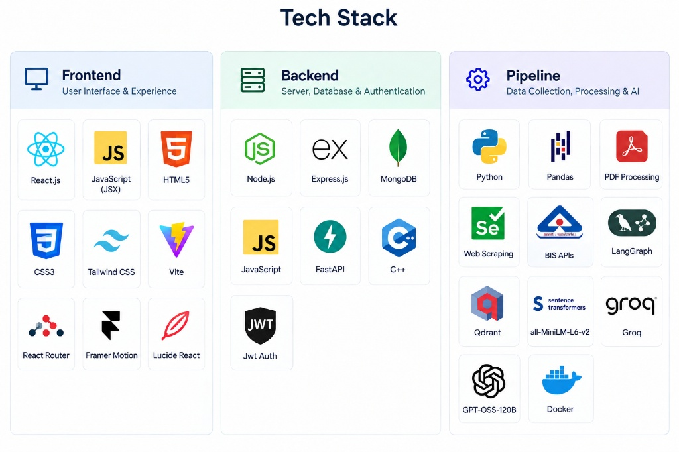
Figure 4.1: Jagruk Swadesh Technology Stack
The platform leverages a modern, decoupled technology stack organized into three domains:
4.1 Frontend
- React.js & Vite: Provides a lightning-fast Single Page Application (SPA) experience.
- Tailwind CSS & Framer Motion: Used for building a responsive, animated, and accessible UI.
- Lucide React & React Markdown: Renders icons and structures LLM text outputs into readable formats.
4.2 Backend
- Node.js & Express.js: Handles business logic, JWT authentication, and acts as a proxy gateway.
- FastAPI (Python): Serves the computationally heavy AI routing, transcription, and LangGraph execution due to Python's dominance in the AI ecosystem.
- MongoDB: NoSQL database for managing user profiles and conversation histories.
4.3 AI / Data Pipeline
- LangGraph: Orchestrates the state-based decision-making loop of the Jagruk Brain.
- Qdrant: High-performance vector database storing the embedded BIS knowledge.
- Sentence Transformers (all-MiniLM-L6-v2): Generates dense vector embeddings for semantic similarity.
- Groq (GPT-OSS-120B): Provides ultra-low latency inference for query understanding and response generation.
- Web Scraping / Playwright: Powers the initial automated data ingestion pipeline.

CHAPTER 5 — BIS DATA COLLECTION AND KNOWLEDGE PREPARATION
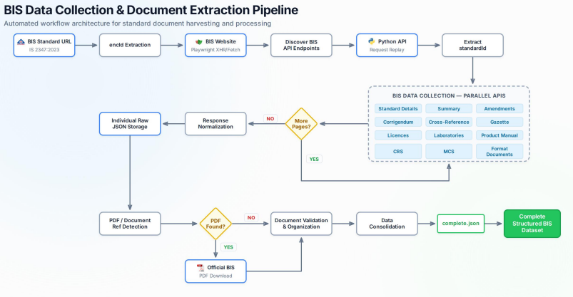
Figure 5.1: BIS Data Collection & Document Extraction Pipeline (Referencing Project Data Architecture)
The foundation of the RAG system is a high-quality dataset. The system employs an automated extraction pipeline:
5.1 to 5.7 Ingestion and Discovery
The pipeline begins at the BIS Standard URL. Using Playwright, the system simulates XHR/Fetch requests to discover hidden BIS API endpoints. Python scripts then replay these requests to extract Standard IDs dynamically.
5.8 Parallel Data Extraction
The pipeline pulls data across multiple categories simultaneously:
- Standard Details & Summaries
- Amendments & Corrigendum
- Cross-References & Gazettes
- Product Manuals & Licenses
5.12 to 5.17 Processing and Consolidation
PDF references are detected and downloaded. The raw data is validated, organized, and consolidated into a master complete.json file. This structured dataset is critical for minimizing noise before chunking and embedding, ensuring the AI has pristine context to draw from.

CHAPTER 6 — RAG KNOWLEDGE BASE
6.1 What is RAG?
Retrieval-Augmented Generation connects an LLM to external data sources. Instead of relying on the model's internal weights (which may be outdated or hallucinated), Jagruk Swadesh retrieves factual BIS documents first.
6.4 to 6.8 Document Preparation & Embedding
The complete.json data is parsed and split into manageable chunks. Each chunk is passed through the all-MiniLM-L6-v2 model to generate a dense numerical vector (embedding).
6.9 Qdrant Vector Database
These vectors are stored in Qdrant. When a user asks a question, their query is also embedded. Qdrant performs a Cosine Similarity search to find the nearest vectors—representing the most relevant BIS clauses.
6.17 Evidence-Grounded Generation
The retrieved chunks are injected into the Groq LLM prompt as strict context. The system is instructed to only answer based on this context, effectively eliminating hallucination.

CHAPTER 7 — JAGRUK BRAIN AI PIPELINE
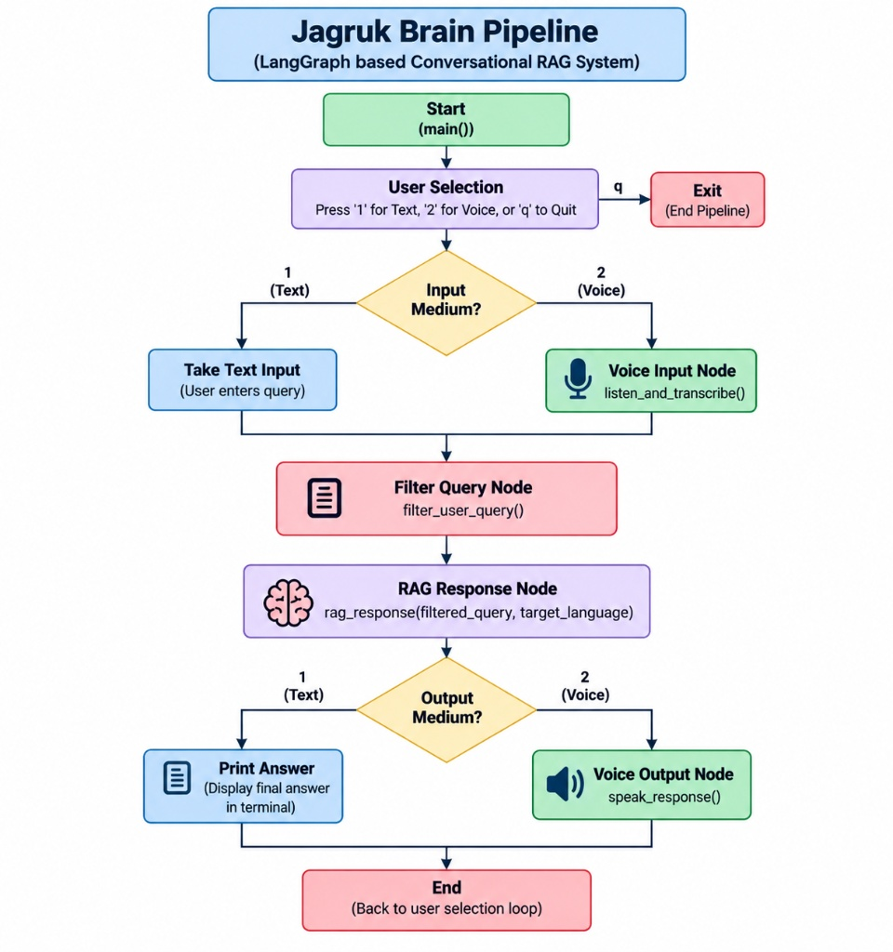
Figure 7.1: Jagruk Brain Pipeline
7.1 Pipeline Overview
The "Jagruk Brain" utilizes a state-based pipeline (implemented via LangGraph concepts) to route data efficiently.
7.4 Text vs 7.5 Voice Input Paths
The system decides the processing path based on the input medium.
- Voice Input Node: Captures audio and sends it to the Whisper model for Speech-to-Text (STT) conversion.
- Text Input: Bypasses STT and moves directly to processing.
7.10 Filter Query Node
Before searching the vector database, the query undergoes preprocessing: identifying the language, extracting the core intent, and identifying product names.
7.17 RAG Response Node
This node queries Qdrant and passes the context to the LLM for reasoning.
7.20 Output Medium Decision
If the user initiated the query via voice, the text response is routed to the Voice Output Node (Edge TTS) to generate spoken audio, closing the conversational loop seamlessly.

CHAPTER 8 — QUERY UNDERSTANDING AND AI REASONING
8.1 Natural Language Understanding
The system intelligently bridges the gap between colloquial queries (e.g., "rules for ceiling fans") and official nomenclature ("IS 374:2019 Electric ceiling type fans").
8.9 Evidence-Grounded Response Generation
Once the formal search terms retrieve the context, the Groq-powered LLM acts as an evaluator. It reads the retrieved text and formulates a response in the user's requested language, ensuring technical parameters (like safety thresholds) are cited exactly as they appear in the source.

CHAPTER 9 — VOICE AND MULTILINGUAL INTERACTION
9.1 Voice Input and Transmission
Users can speak directly into the browser UI. The frontend records an audio blob and POSTs it to the backend.
9.5 Whisper
The system utilizes Whisper for highly accurate, multilingual Speech-to-Text transcription. Whisper handles regional accents effectively.
9.8 Text-to-Speech
Responses generated by the AI are converted back to audio using TTS libraries, ensuring accessibility for users who prefer auditory learning or face literacy barriers.

CHAPTER 10 — FRONTEND APPLICATION
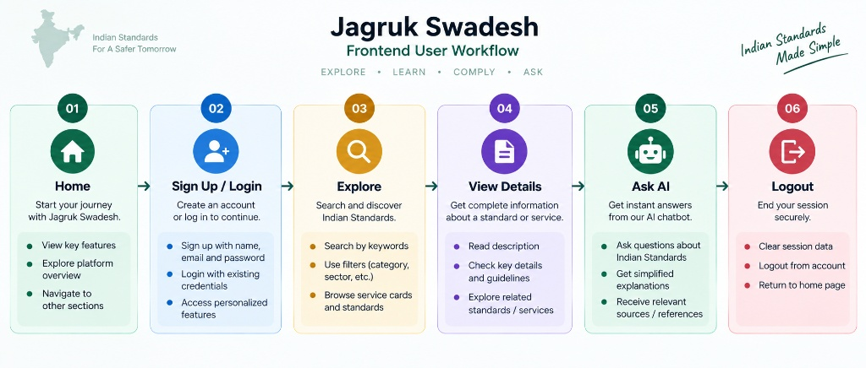
Figure 10.1: Jagruk Swadesh Frontend User Workflow
The frontend provides an intuitive, accessible journey.
10.1 to 10.6 User Journey
- Home: Landing page explaining the value proposition.
- Sign Up / Login: Secure access to personalized features.
- Explore: Categorized search for specific standards.
- Ask AI: The core chat interface handling markdown text and voice interactions.
10.7 React Architecture
Built with Vite for rapid module replacement, the UI uses functional components and React hooks for state management. Tailwind CSS ensures the application is responsive across mobile and desktop devices.

CHAPTER 11 — BACKEND ARCHITECTURE
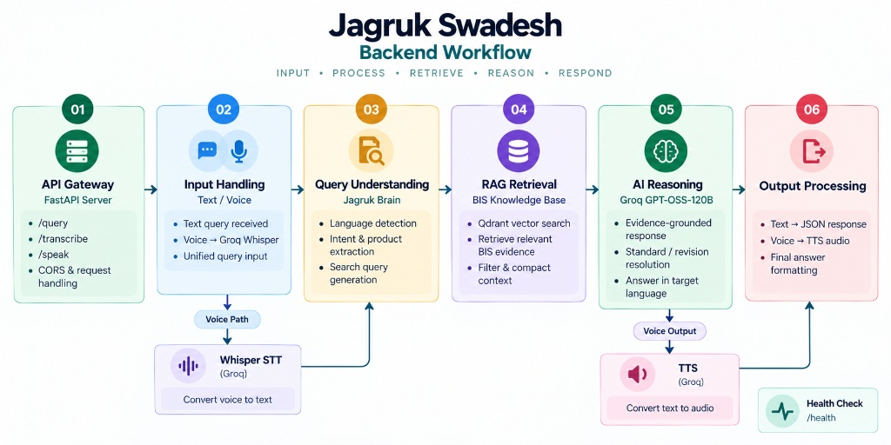
Figure 11.1: Jagruk Swadesh Backend Workflow
11.1 API Gateway
The backend bridges the user interface with the AI processing layer. An Express.js server handles standard HTTP requests, authenticates users, and proxies complex AI tasks to a dedicated FastAPI service.
11.8 to 11.10 Endpoints
- Input Handling: Accepts raw text or audio.
- Query Understanding: Routes to Jagruk Brain.
- RAG Retrieval & AI Reasoning: Interfaces with Qdrant and Groq.
- Output Processing: Formats JSON responses or audio streams.
CHAPTER 12 — API DESIGN AND DATA FLOW
Table 12.1: API Endpoints
Endpoint | Method | Purpose | Payload / Processing
/api/auth/signup | POST | User registration | Hashes password, saves to Mongo
/api/auth/login | POST | User login | Validates credentials, returns JWT
/query | POST | Text AI Query | Receives text, triggers RAG
/transcribe | POST | Audio processing | Receives audio file, uses Whisper STT
/speak | POST | Audio generation | Receives text, returns TTS stream
/health | GET | System status | Checks service uptime

CHAPTER 13 — DATABASE AND DATA MANAGEMENT
13.1 Application Database
MongoDB (via Mongoose) stores user credentials securely, managing application state, sessions, and configuration metadata.
13.10 Vector Database
Qdrant is strictly isolated for AI vector search. It stores the multidimensional embeddings of the BIS text chunks, allowing rapid semantic similarity calculations at scale.
CHAPTER 14 — SECURITY
14.1 Authentication & Protection
- JWT: Secures API routes and maintains stateless sessions.
- Password Hashing: Passwords are encrypted before database insertion.
- Environment Variables: Sensitive keys (Groq API, Qdrant credentials, JWT secrets) are kept out of source code.
- CORS: Explicitly configured to prevent unauthorized cross-origin requests.

CHAPTER 15 — TESTING AND VALIDATION
Table 15.1: Recommended Test Cases
Test ID | Module | Test Scenario | Expected Result
TC01 | Auth | Login with valid JWT | 200 OK, User Profile returned
TC02 | AI Brain | Query generic greeting | Direct LLM response (No RAG)
TC03 | AI Brain | Query specific IS standard | Retrieve exact context, factual response
TC04 | Voice | Upload clear audio query | Accurate text transcription

CHAPTER 16 — DEPLOYMENT AND SETUP
16.1 Development Environment
Requires Node.js for the frontend/gateway and Python 3.10+ for the FastAPI service.
16.13 Recommended Production Architecture
- Frontend: Deployed to Vercel for global CDN edge caching.
- Backend Services: Hosted on Railway for seamless Dockerized deployment.
- Databases: MongoDB Atlas (Application) and Qdrant Cloud (Vector).

CHAPTER 17 — PERFORMANCE, SCALABILITY AND RELIABILITY
The microservices design allows the FastAPI heavy-computation node to be scaled independently of the Express web server. Qdrant is inherently scalable for millions of vectors, ensuring retrieval times remain in the low milliseconds regardless of dataset size.

CHAPTER 18 — LIMITATIONS AND CHALLENGES
- API Dependency: Reliant on external uptime (Groq, Qdrant).
- Speech Recognition: Heavy background noise can degrade Whisper STT accuracy.
- Data Freshness: BIS documents update frequently; the vector DB requires periodic re-syncing to avoid serving deprecated standards.

CHAPTER 19 — FUTURE SCOPE
- Continuous Synchronization: Automated webhooks to update the vector database whenever a new standard is gazetted.
- More Indian Languages: Expanding TTS and STT to fully support deep regional dialects.
- Manufacturer Portals: Dashboards for businesses to track their specific compliance journey based on AI recommendations.

CHAPTER 20 — IMPACT AND BENEFITS
Jagruk Swadesh directly tackles the friction of regulatory compliance. By turning monolithic legal texts into conversational, accessible interactions, it reduces the knowledge gap between policymakers and citizens, fundamentally aiding in the digital transformation of India's manufacturing and consumer safety sectors.

CHAPTER 21 — CONCLUSION
Jagruk Swadesh successfully implements a state-of-the-art conversational RAG system tailored specifically for Indian regulatory compliance. By orchestrating a modern React frontend, a robust Node/FastAPI backend, and the LangGraph-powered "Jagruk Brain," the platform achieves accurate, fast, and secure information retrieval. Integrating voice capabilities and semantic search fundamentally transforms the user experience from manual document hunting to seamless dialogue, proving the project's core thesis: "Indian Standards Made Simple."

APPENDICES
APPENDIX A: Project Directory Structure Contains isolated directories for /frontend, /backend, and /ai_pipeline, enforcing separation of concerns.
APPENDIX B: Technology Stack Comprehensive listing of package dependencies (React, Express, FastAPI, LangChain, Qdrant-client).
APPENDIX C: Environment Variables Required keys: MONGO_URI, JWT_SECRET, GROQ_API_KEY, QDRANT_URL. (Actual values excluded for security).

WEBSITE UI
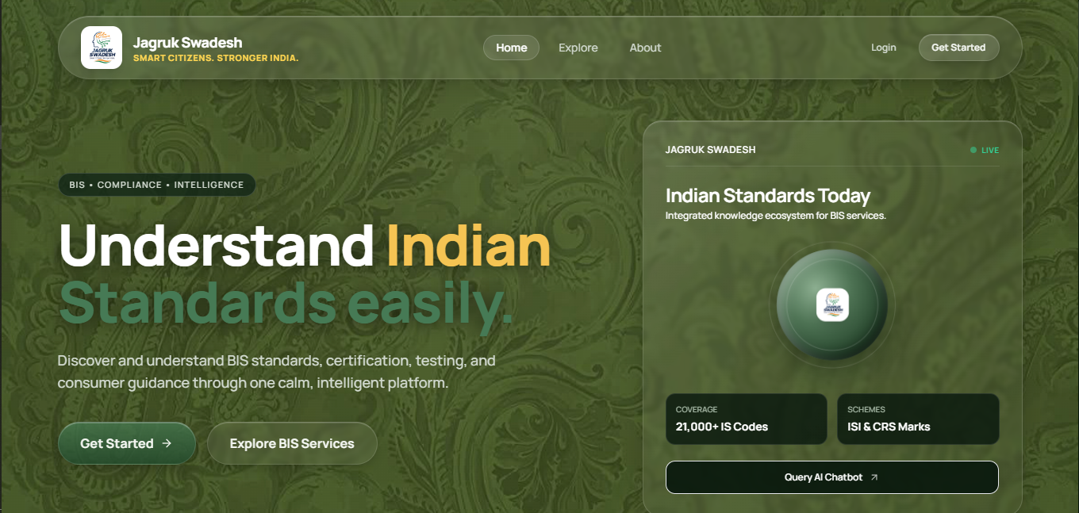
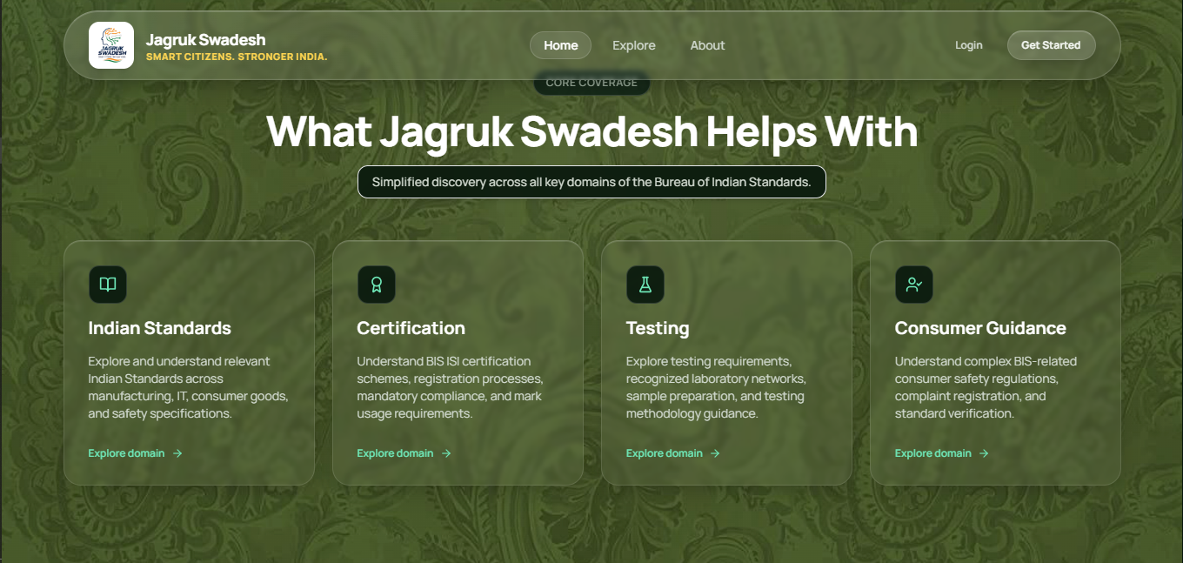
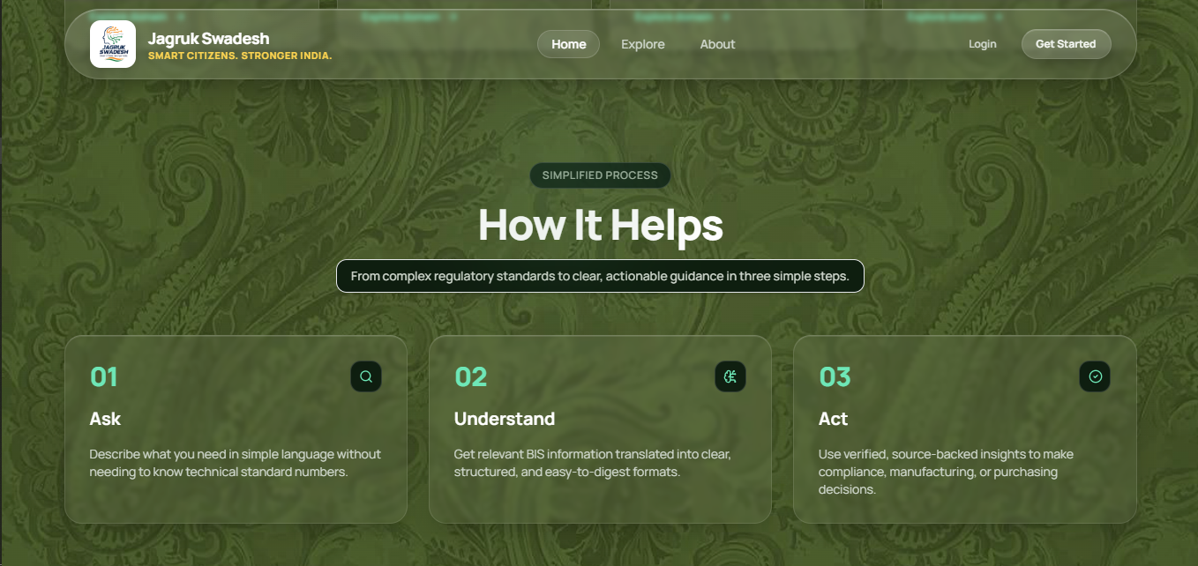

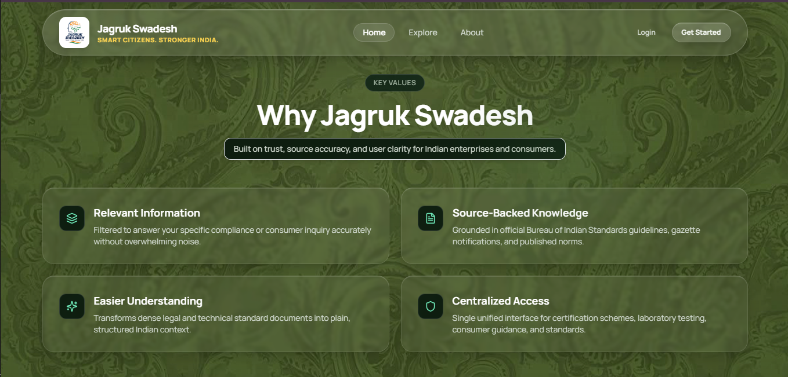
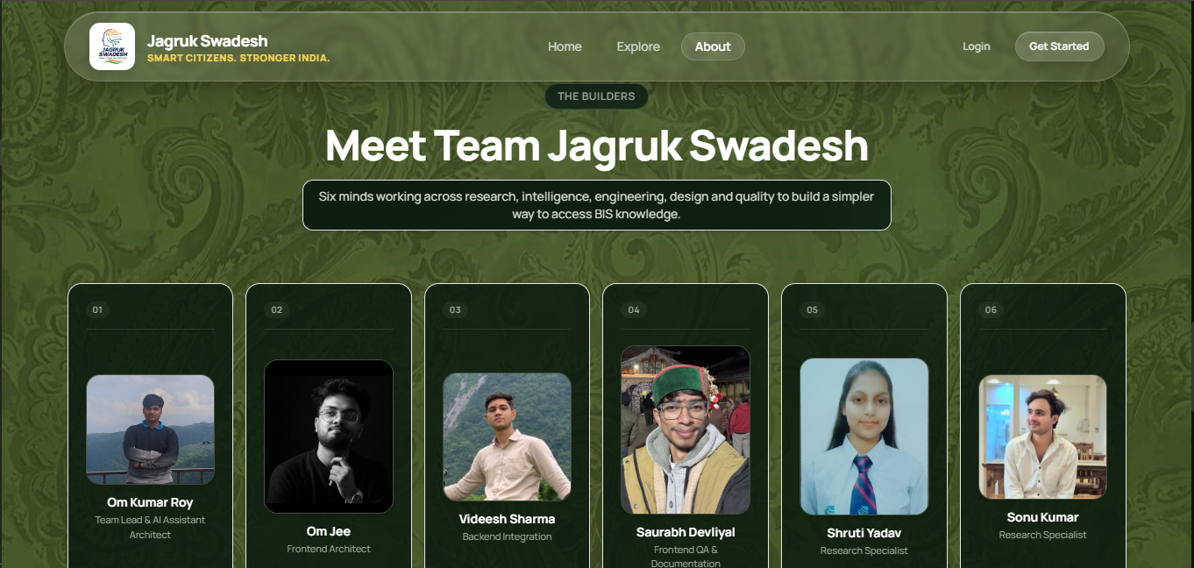

CHATBOT UI AND RESPONSE
